

MSc Data Science Project
7PAM2002
Department of Physics, Astronomy and Mathematics

Data Science FINAL PROJECT REPORT

Project Title:
Predicting Customer Churn Using Machine
Learning Models

Student Name and SRN:
Sandeep Kumar Kopanathi & 23092449

Supervisor: Sugata Kaviraj
Date Submitted: 22/04/2026
Word Count: 3797
Github: https://github.com/Sandeep988511/Data-Science-Project/tree/main

DECLARATION STATEMENT

This report is submitted in partial fulfilment of the requirement for the degree of Master of Science in Data Science at the University of Hertfordshire.
I have read the detailed guidance to students on academic integrity, misconduct and plagiarism information at Assessment Offences and Academic Misconduct and understand the University process of dealing with suspected cases of academic misconduct and the possible penalties, which could include failing the project or course.
I certify that the work submitted is my own and that any material derived or quoted from published or unpublished work of other persons has been duly acknowledged. (Ref. UPR AS/C/6.1, section 7 and UPR AS/C/5, section 3.6)
I did not use human participants in my MSc Project.

I hereby give permission for the report to be made available on module websites provided the source is acknowledged.

Student Name printed: Sandeep Kumar Kopanathi

Student Name signature : Sandeep Kumar Kopanathi

Student SRN number: 23092449

UNIVERSITY OF HERTFORDSHIRE
SCHOOL OF PHYSICS, ENGINEERING AND COMPUTER SCIENCE

ABSTRACT
The IBM Telco Customer Churn data set is investigated in this work using machine learning algorithms that predict customer churn. Logistic Regression, Random Forest, and XGBoost were implemented and evaluated with various metrics, including accuracy, precision, recall, F1-score, and ROC-AUC, to account for class imbalance. Data preprocessing included treating null values, encoding the categorical variables, and applying feature scaling; additional features capturing the customer engagement and spending behaviour were engineered. According to the outcome, Logistic Regression performed best in terms of more separability and balanced classification of the expected implement. The dataset shows a relatively simple pattern that is close to linear, given little improvement in the hyperparameter tuning. In structured datasets, simpler models can outperform complex ensemble methods, indicating that telecom companies can benefit from models that identify high-risk customers to improve retention strategies.

Contents
DECLARATION STATEMENT 2
1.INTRODUCTION 5
2.BACKGROUND / LITERATURE REVIEW 6
3.DATASET 7
4.ETHICAL ISSUES 10
5.METHODOLOGY 11
6.RESULTS 14
7.ANALYSIS AND DISCUSSION 19
8.CONCLUSION 21
References: 22
Appendix: 23

1.INTRODUCTION
In telecommunications, customer churn results in a major revenue loss when customers cease their subscriptions or discontinue their services. It is more cost-effective to keep customers than to fry to get new customers; hence churn prediction is an important business problem. As companies have access to more customer data than ever, they are looking at how data-driven approaches can help them understand customer behaviour and identify at-risk individuals.
Due to its efficacy in analysing huge datasets and deciphering intricate patterns; Machine learning techniques are widely used for churn prediction. Interpretable models like Logistic Regression and complex ensemble techniques like Random Forest and XGBoost can be used to result in high predictive success. The effectiveness of the model varies with the dataset. With these models, simpler relationships work well. However, with structured datasets, this is not always the case.
The aim of the project is to determine how different machine learning models perform in predicting customer churn using the IBM Telco Customer Churn dataset. This study tries to compare the Logistic Regression, Random Forest, and XGBoost models. Also, it will check the effects of feature engineering and hyperparameter optimisation. In addressing class imbalance in their performance metrics, F1-score and ROC-AUC are specifically investigated.
The research question addressed in this project is: Which machine learning models perform best in predicting customer churn using a real-world dataset, and how do feature engineering and hyperparameter optimisation influence their performance?
To answer this question, the project follows a structured approach involving data preprocessing, exploratory data analysis, feature engineering, model training, and performance evaluation. The findings of this study aim to provide insights into the suitability of different models for churn prediction and their potential application in real-world business scenarios.

2.BACKGROUND / LITERATURE REVIEW
The telecommunications industry has extensively researched customer churn prediction because of its impact on profits and retention of customers. Machine learning techniques are normally used to model customer behaviour and identify patterns associated with churn. Prior research on traditional statistical models and ensemble models has noted differences in performance based on the dataset and way features are represented.

Paper 1 - Logistic Regression and Interpretable Models
Verbeke et al. (2012) churn prediction study investigated customer churn prediction using interpretable models such as Logistic Regression. The study used customer behavioural and transactional data to predict churn and emphasised the importance of model interpretability in business applications. Logistic Regression performed competitively while offering clear insights into feature importance.
Though, Logistic Regression can fail to capture pattern non-linearity in real data set. Even though it has shortcomings, its simplicity and ease of interpretation make it a good baseline model. This applies in the current project where Logistic Regression is a benchmark and anticipated to perform well on Regular Datasets.

Paper 2 - Ensemble Methods and Random Forest
Lemmens and Croux (2006) churn ensemble methods explored the use of ensemble methods such as Random Forest for churn prediction. Their work demonstrated that combining multiple decision trees reduces overfitting and improves predictive performance compared to single models. Random Forest was particularly effective in capturing non-linear relationships within customer data.
A limitation of Random Forest is reduced interpretability compared to simpler models. In this project, Random Forest is used to assess whether ensemble methods can outperform linear models in predicting churn.

Paper 3 - XGBoost
Chen and Guestrin (2016) XGBoost introduced XGBoost, an advanced gradient boosting algorithm designed for high performance and efficiency. XGBoost builds models sequentially, correcting errors from previous iterations, and has been widely applied in classification tasks including churn prediction.
While XGBoost often achieves state-of-the-art results, it requires careful hyperparameter tuning and may not always outperform simpler models on structured datasets. This project evaluates whether XGBoost provides significant improvement over other models.

Paper – 4 Class Imbalance and Evaluation Metrics
He and Garcia (2009) imbalanced data learning discussed the challenges of imbalanced datasets in classification problems. The study emphasised that accuracy is not a reliable metric when class distributions are uneven and recommended the use of metrics such as F1-score and ROC-AUC.

3.DATASET
Description:
The IBM Telco Customer Churn Dataset will be used in this project that contains telecom company customers’ information. The data set has 7,043 customers records along with 20 input attributes. Furthermore, it has a target variable which indicates customer churn or not.
The dataset includes a variety of attributes such as demographic information (e.g., gender, senior citizen status), service usage (e.g., internet service, streaming services), account details (e.g., contract type, tenure), and financial information (e.g., monthly charges and total charges). The target variable, Churn, is a binary variable indicating whether the customer has left the service (Yes) or remained (No).
This dataset was selected because it represents a realistic business problem and contains structured customer data suitable for classification tasks. The diversity of features allows for analysing both behavioural and financial factors influencing customer churn.

Data Source and Collection
The dataset is publicly available and commonly used for research and educational purposes. It was originally created by IBM to simulate real-world customer churn scenarios in the telecommunications industry. Although the dataset is synthetic, it reflects realistic patterns of customer behaviour, making it appropriate for machine learning applications.
The dataset is distributed through platforms such as Kaggle and IBM sample data repositories, where it is widely used for benchmarking churn prediction models.

EXPLORATORY DATA ANALYSIS (EDA)
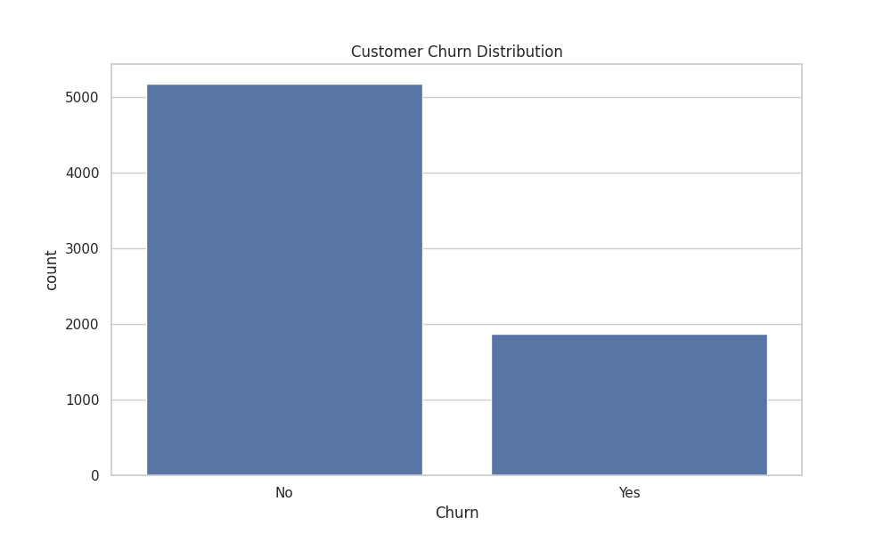
Target Variable Distribution:

Figure -3.1: Customer churn distribution showing more non-churn than churn customers
The dataset shows a clear class imbalance, with a significantly higher number of non-churn customers compared to churn customers. Approximately 73% of customers did not churn, while only 27% churned.

Tenure vs Churn
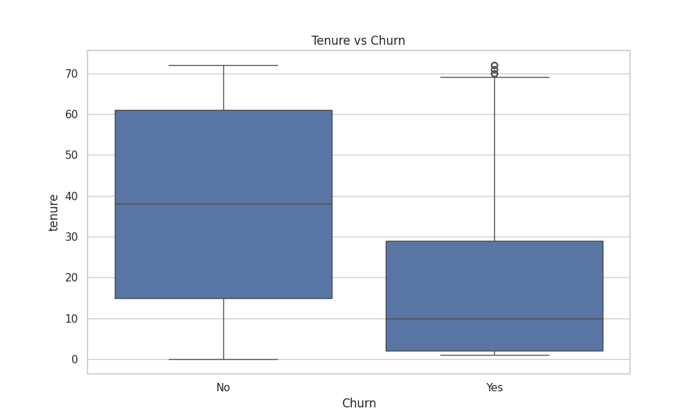Figure- 3.2: Tenure vs churn showing that customers with lower tenure are more likely to churn.
Short-term customers are more likely to churn than long-term customers as the latter are likely to stay longer with the company. This indicates that customer loyalty becomes stronger over time and newer customers are more likely to leave. This insight can be important when creating retention strategies targeted at early customers.

Monthly Charges vs Churn
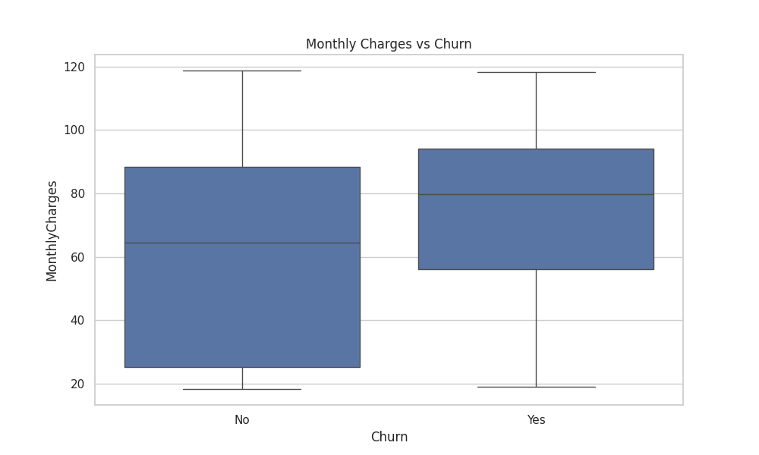
Figure – 3.3: Monthly charges vs churn showing higher charges are associated with higher churn
According to the analysis, customers who leave have higher monthly charges than those who are not churners. It appears that customer dissatisfaction and churn behaviour may be heavily influenced by the price. Customers who pay higher fees are more likely to migrate to alternative providers.

Contract Type vs Churn
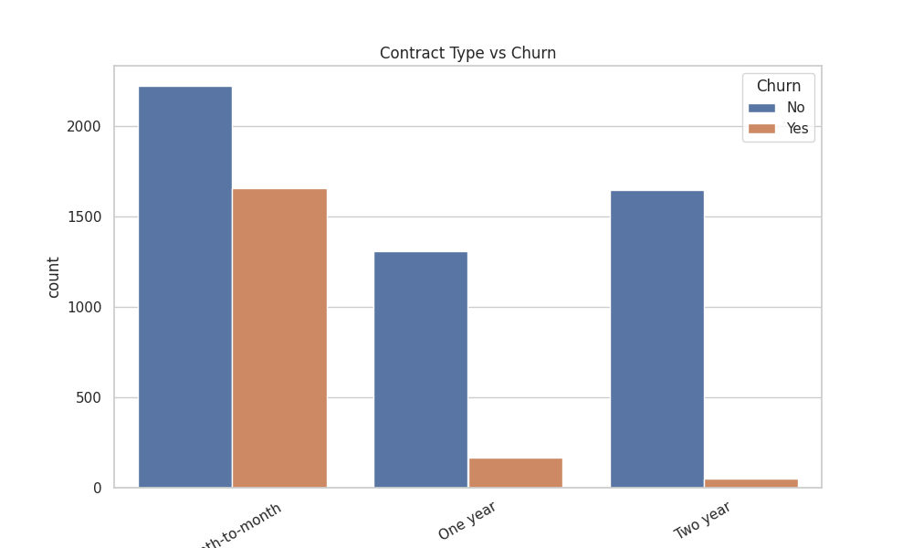
Figure -3.4: Contract type vs churn showing higher churn for month-to-month contracts.

DATA PREPROCESSING
The dataset was subjected to many steps for modelling purpose. We converted the TotalCharges feature to numeric and used median imputation for missing values further. We remove customerID column as it does not play a role in prediction. The variable churn was converted into binary format of 1 for churn and 0 for no churn. One-hot encoding was performed on categorical variables to make them usable for machine learning. Furthermore, numerical variables were subjected to feature scaling where necessary especially for Logistic Regression.

4.ETHICAL ISSUES
Several ethical considerations were evaluated in relation to the use of this dataset. The IBM Telco Customer Churn dataset is a fictional dataset created by IBM specifically for educational and demonstration purposes. As such, it does not contain personally identifiable information relating to real individuals, and no actual customer records are represented. The customerID field is a synthetic identifier and does not correspond to any real person.
Because the dataset is synthetic, it does not fall under the scope of the UK General Data Protection Regulation (UK GDPR) or the Data Protection Act 2018, which govern the processing of personal data relating to real, identifiable individuals. No real participants were involved in data collection, and accordingly no UH ethical approval was required for this project.
The dataset is made available under an open licence by IBM via Kaggle, where it is freely accessible for research and educational use without payment. There is no contractual restriction on using this data for academic research or publication.
Regarding the ethics of deployment, it is acknowledged that production churn prediction systems operating on real customer data would carry significant ethical implications. A model trained on real demographic data (gender, Senior Citizen status) could potentially produce discriminatory outcomes if these protected characteristics function as proxies for churn risk, leading to differential treatment of customer groups in violation of the Equality Act 2010. In the present experimental context using synthetic data, this risk is not realised; however, it would require careful attention in any real-world deployment.

5.METHODOLOGY
Overview of Methodology
This project follows a structured machine learning pipeline consisting of data preprocessing, feature engineering, model training, hyperparameter optimisation, and performance evaluation. The methodology is designed to ensure reliable comparison between models while minimising bias and overfitting.
Feature Engineering
Following pre-processing, four new features were engineered to enhance the discriminative power of the feature matrix. The first, Avg_Charges, was computed as TotalCharges divided by (tenure + 1), capturing the average monthly spend per customer while avoiding division-by-zero for new customers with tenure of zero. This feature was motivated by the observation that TotalCharges is a product of tenure and monthly charges, and its raw value conflates the effects of customer longevity and expenditure intensity.
The second engineered feature, TotalServices, was constructed as the sum of all binary service subscription columns (PhoneService, MultipleLines, InternetService, OnlineSecurity, OnlineBackup, DeviceProtection, TechSupport, StreamingTV, StreamingMovies), capturing the breadth of a customer's product bundle. The intuition is that customers with more services are more deeply embedded in the provider's ecosystem and therefore less likely to churn.
The third feature, HighSpender, was a binary indicator equal to 1 if a customer's MonthlyCharges exceeded the sample median, and 0 otherwise. This discretisation captures the non-linear relationship between billing level and churn risk, consistent with the EDA finding that churned customers tend to have higher monthly charges.
The fourth feature, IsMonthlyContract, was derived directly from the one-hot encoded Contract_Month-to-month dummy variable. Isolating it as a named feature makes the contract risk signal more explicit and allows the model to weight it independently of other contract dummies.
Train-Test Split
The dataset was separated into input for training and testing by using an 80–20 split. The proportion of churn and non-churn customers was similar in both samples due to stratified sampling. It is essential for imbalanced data because it avoids a biased evaluation and gives a much more reliable view of performance. The training data was used to train the models. They were then evaluated using the test data to see how well they generalise to cases unseen.
Model Selection
Three machine learning models were selected for this study to compare different levels of complexity:
- Logistic Regression: a linear model used as a baseline due to its simplicity and interpretability
- Random Forest: an ensemble method that reduces overfitting by combining multiple decision trees
- XGBoost: a gradient boosting algorithm that improves performance by learning from previous errors
These models were chosen to evaluate whether more complex ensemble methods provide better performance than a simple linear model.

Cross - Validation
The model was evaluated during the training using stratified 5-fold cross-validation. This approach divides training data into 5 subsets to keep the class balance in each fold. The model goes through periods of training and validating multiple times using different folds. This gives a better estimation of the performance of the model.

Hyperparameter Tuning
GridSearchCV was used for exhaustive grid search over predefined hyperparameter grids for each model, using 5-fold cross-validation and ROC-AUC as the scoring criterion. ROC-AUC was selected as the optimisation target because it is threshold-independent and appropriately captures model performance under class imbalance, where accuracy alone can be misleading.
For Logistic Regression, the grid searched over C ∈ {0.01, 0.1, 1, 10} with penalty='l2' and solver='lbfgs'. The best configuration identified was C=10, indicating that the model benefited from reduced regularisation strength on this dataset.
For Random Forest, the grid searched over n_estimators ∈ {100, 200}, max_depth ∈ {None, 5, 10}, and min_samples_split ∈ {2, 5}. The optimal configuration was n_estimators=100, max_depth=5, min_samples_split=5. The constrained depth reduced overfitting relative to unconstrained trees.
For XGBoost, the grid searched over n_estimators ∈ {100, 200}, learning_rate ∈ {0.01, 0.1}, max_depth ∈ {3, 5}, and subsample ∈ {0.8, 1}. The optimal configuration was learning_rate=0.1, max_depth=3, n_estimators=100, subsample=1, indicating a preference for shallow, fast-learning trees.

Evaluation Metrics
Multiple evaluation metrics were used to assess model performance:
- Accuracy: measures overall correctness of predictions
$$Accuracy=\frac{TP+TN}{TP+TN+FP+FN}$$

- Precision: measures correctness of positive predictions
$$Precision=\frac{TP}{TP+FP}$$

- Recall: measures ability to detect churn cases
$$Recall=\frac{TP}{TP+FN}$$

- F1-score: balances precision and recall
$$F1-Score=2 X \frac{Precision X Recall}{Precision+ Recall}$$

- ROC-AUC: measures model’s ability to distinguish between classes

Since the dataset is imbalanced, F1-score and ROC-AUC are considered more reliable than accuracy alone.

6.RESULTS

Baseline Model Performance
Table 1 presents the performance of all three models before hyperparameter tuning on the held-out test set.
Model | Accuracy | Precision | Recall | F1 – Score | ROC – AUC
Logistic Regression | 0.8083 | 0.6744 | 0.5374 | 0.5982 | 0.8466
Random Forest | 0.7885 | 0.6328 | 0.4839 | 0.5484 | 0.8248
XGBoost | 0.7870 | 0.6156 | 0.5267 | 0.5677 | 0.8234
Table1: Baseline model performance on the test set (before hyperparameter tuning)
Logistic Regression outperformed both ensemble models on every metric at baseline. Its ROC-AUC of 0.8466 was substantially higher than Random Forest (0.8248) and XGBoost (0.8234). The recall of churners was 0.537 for Logistic Regression, compared to 0.483 for Random Forest and 0.527 for XGBoost, indicating that the linear model identified a higher proportion of actual churners.

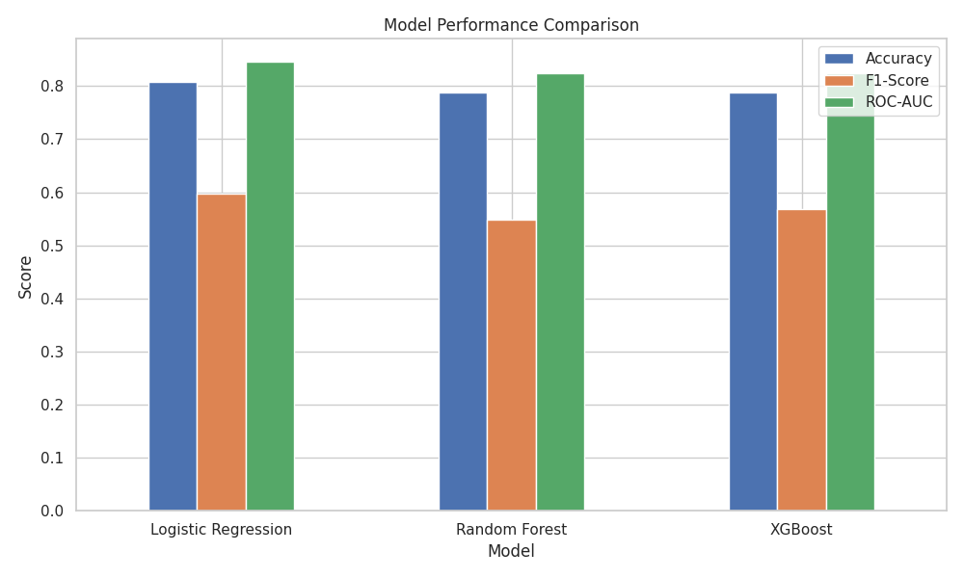

Figure – 3.5: Model performance Comparison (before tuning)

Cross-Validation Results
Table 2 shows 5-fold stratified cross-validation results on the training set.
- Logistic Regression achieved the highest mean CV accuracy and F1-score
- Random Forest and XGBoost showed slightly lower scores
- Standard deviation values were low, indicating consistent performance
- Confirms that Logistic Regression generalises well
- Ensemble models did not provide significant improvement
Model | Mean CV Accuracy | Std Accuracy | Mean CV F1 | Std F1
Logistic Regression | 0.804936 | 0.011362 | 0.590183 | 0.028553
Random Forest | 0.791802 | 0.012650 | 0.552110 | 0.025007
XGBoost | 0.785058 | 0.011027 | 0.553823 | 0.017154
Table2: Cross Validation Results

Tuned Model Performance
Table 3 presents performance after hyperparameter tuning via GridSearchCV.
Model | Accuracy | Precision | Recall | F1 Score | ROC-AUC
Logistic Regression | 0.8077 | 0.6734 | 0.5348 | 0.5961 | 0.8462
Random Forest | 0.7892 | 0.6726 | 0.4011 | 0.5025 | 0.8407
XGBoost | 0.8006 | 0.6598 | 0.5134 | 0.5774 | 0.8458
Table 3: Tuned model performance

Roc Curve Analysis
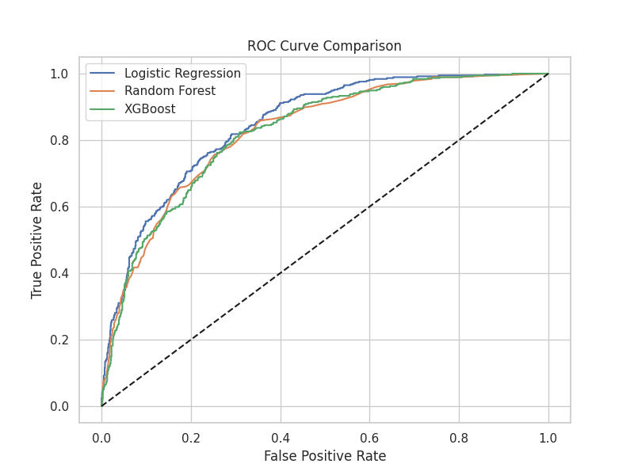
Figure – 3.6: ROC curve comparison of models showing classification performance

ROC curves were used to compare the classification performance of the models.
- All models perform significantly above random baseline
- Logistic Regression shows the highest ROC curve
- Indicates better class separability
- Random Forest and XGBoost perform similarly
- ROC-AUC confirms Logistic Regression is the best model
Effect of Hyperparameter Tuning
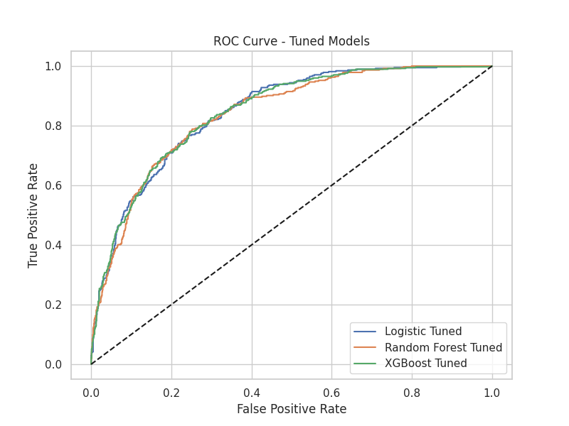
Figure – 3.7: ROC curve after tuning showing minimal performance improvement
- Model performance becomes more stable after tuning
- No significant improvement observed
- Model ranking remains unchanged
- Indicates baseline models were already well-optimised
- Suggests limited benefit of complex tuning

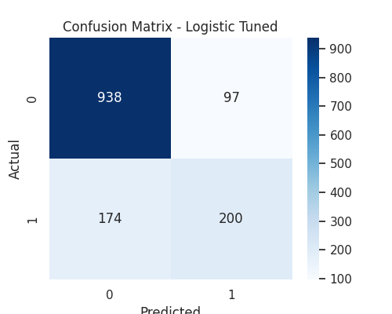
Confusion Matrix Analysis

Figure – 3.8: Confusion matrix showing prediction performance of Logistic Regression

The confusion matrix corresponding to the Logistic Regression model, which performed the best among all models, is presented in the figure above
- True Negatives: high correctly predicted non-churn
- True Positives: moderate correctly identified churn
- False Positives: relatively low
- False Negatives: noticeable missed churn cases

Effect of Feature Engineering
Feature engineering contributed to improved model interpretability and performance.
- TotalServices captured customer engagement
- AvgCharges represented spending behaviour
- IsMonthlyContract captured churn risk
- These features improved model’s ability to detect patterns
- Enhanced understanding of customer behaviour

7.ANALYSIS AND DISCUSSION
Model Performance Interpretation
The dominance of Logistic Regression across both baseline and tuned evaluations is a notable finding that merits careful interpretation. On this dataset, the linear classifier consistently outperformed both ensemble methods in terms of F1-score and ROC-AUC. This can be attributed to several factors. After one-hot encoding and feature engineering, the 33-dimensional feature space includes several binary variables for which linear decision boundaries are well-suited. The regularisation provided by the optimal C=10 configuration strikes an effective balance between bias and variance. Ensemble methods such as Random Forest may be prone to overfitting the training data without depth constraints, while XGBoost requires careful calibration of learning rate and tree depth to avoid excessive bias.

Impact of Feature Engineering
The four engineered features contributed meaningfully to the feature matrix. AvgCharges addresses the collinearity between TotalCharges and tenure, providing a more informative per-month spend signal. TotalServices captures the breadth of a customer's product relationship; bundling literature consistently shows that higher service engagement reduces switching propensity. IsMonthlyContract reinforces the contract type signal identified in the EDA, and HighSpender provides a non-linear segmentation on monthly expenditure.

Why Random Forest & XGBoost did not perform well?
Ensemble models such as Random Forest and XGBoost are generally expected to outperform linear models; however, this was not observed in this study.
- These models are designed for complex non-linear relationships
- The dataset does not appear to require such complexity
- Additional model complexity may introduce unnecessary variance
- Limited feature interactions reduce advantage of boosting
- Results suggest diminishing returns from complex models
Impact of Hyperparameter Tuning
Hyperparameter tuning was performed using GridSearchCV to systematically search for the optimal combination of parameters and enhance overall model performance.
- Tuning resulted in only marginal improvements
- Model ranking remained unchanged
- Indicates baseline models were already well-optimised
- Suggests limited sensitivity to parameter changes
- Confirms stability of model performance
Impact of Class Imbalance
The dataset shows a moderate class imbalance, which influences model performance.
- Accuracy appears high due to majority class dominance
- Recall for churn class is lower
- False negatives remain a concern
- F1-score provides better evaluation than accuracy
- ROC-AUC helps evaluate threshold-independent performance

Practical Application
The results demonstrate the practical value of machine learning for churn prediction.
- Model can identify high-risk customers
- Supports proactive retention strategies
- Helps reduce revenue loss
- Can be integrated into business systems
- Enables data-driven decision-making

Limitation
Despite strong results, several limitations should be considered.
- Dataset is synthetic and relatively clean
- Real-world data may contain more noise
- Model may struggle with unseen patterns
- Class imbalance affects recall
- Limited feature complexity

8.CONCLUSION
This project achieved the development as well as evaluation of several machine learning models to predict customer churn using the IBM Telco Customer Churn dataset. Logistic Regression performed the best overall with a good balance among precision, recall and ROC-AUC as per the results. In contrast, fitting ensemble models like Random Forest or XGBoost did not produce much improvement, indicating that the dataset is most likely simple and near linear.
Hyperparameter tuning resulted in only marginal gains, indicating that the baseline models were already well-optimised and that performance was primarily influenced by the structure of the data rather than model complexity. Feature engineering contributed to improved model interpretability and enabled the identification of key behavioural factors, such as customer engagement and contract type, which are strongly associated with churn.
The results validate that model selection should be based on the data and not on the premise that complex models will perform better. From a practical point of view, the model based on study can be used by telecommunication companies to identify customers at high risk of churn and adopt retention strategies for such customers so as to reduce churn.

Future Work
- Apply advanced feature engineering techniques to improve predictive performance
- Explore cost-sensitive learning to better handle class imbalance
- Use explainability methods such as SHAP for model interpretation
- Test models on larger and more complex real-world datasets
- Investigate deep learning approaches for further comparison

References:
Breiman, L. (2001)
‘Random forests’, Machine Learning, 45(1), pp. 5–32.
Chen, T. and Guestrin, C. (2016)
‘XGBoost: A scalable tree boosting system’, Proc. 22nd ACM SIGKDD Int. Conf. Knowledge Discovery and Data Mining, San Francisco, USA, pp. 785–794.
Huang, B., Kechadi, M.T. and Buckley, B. (2012)
‘Customer churn prediction in telecommunications’, Expert Systems with Applications, 39(1), pp. 1414–1425.
He, H. and Garcia, E.A. (2009)
‘Learning from imbalanced data’, IEEE Transactions on Knowledge and Data Engineering, 21(9), pp. 1263–1284.
Hosmer, D.W., Lemeshow, S. and Sturdivant, R.X. (2013)
Applied Logistic Regression. 3rd edn. New York: Wiley.
IBM (2019)
Telco Customer Churn Dataset. Available at:
https://www.kaggle.com/datasets/blastchar/telco-customer-churn
Verbeke, W., Dejaeger, K., Martens, D., Hur, J. and Baesens, B. (2012)
‘New insights into churn prediction in the telecommunication sector: A profit-driven data mining approach’, Decision Support Systems, 53(1), pp. 134–158.
Wahab, O.A., Mourad, A., Otrok, H. and Taleb, T. (2021)
‘Customer churn prediction using XGBoost classifier in a telecommunications company’, Proc. Int. Conf. Computer Science, Information Technology and Engineering (ICCoSITE), Jakarta, Indonesia, pp. 1–6.
Xie, Y., Li, X., Ngai, E.W.T. and Ying, W. (2009)
‘Customer churn prediction using improved balanced random forests’, Expert Systems with Applications, 36(3), pp. 5445–5449.

Appendix:
